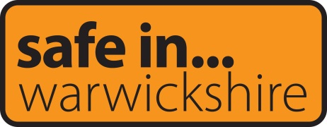
Warwickshire Community Safety Agreement 2022-26

Forward
I am very pleased to introduce the Warwickshire Community Safety Agreement which sets out the long-term strategic ambitions of the Safer Warwickshire Partnership Board.

The years since the previous Warwickshire Community Safety Agreement was produced in 2017 have been a time of great change, both to the community safety landscape and the wider societal context in which this work sits. The COVID-19 pandemic has changed the world in which we live and work beyond all recognition, with long-term impacts on crime levels and community cohesion still to be fully understood.

From a Community Safety perspective, there has been a wide range of national and local legislation and developments impacting on the work of partner agencies. These include:
- The Police, Crime, Sentencing and Courts Bill sets out a statutory duty for named agencies to work together to prevent and reduce serious violence, and to prepare and implement a strategy for preventing and reducing serious violence in the area. The adoption of a Public Health approach is strongly encouraged.
- The 2019 Serious Violence Fund led to the formation of Violence Reduction Units (VRUs) in the 18 police force areas worst affected by serious violence. Although Warwickshire does not have its own Violence Reduction Unit, it is a net importer of serious violence and County Lines activity and close links are being established with the interventions being developed in Coventry through the West Midlands VRU.
- The Domestic Abuse Act 2021 introduced a range of new measures, including the first statutory definition of Domestic Abuse, new Domestic Abuse Protection Notices and Orders, greater support for victims testifying in Court and a national Domestic Abuse Strategy. It also placed a duty on local authorities in England to provide accommodation based support to victims of Domestic Abuse and their children. In response to this duty, the Warwickshire Safe Accommodation Strategy 2021-24 was published in September 2021.
- The horrific murder of Sarah Everard in London in March 2021 opened up a national debate about the safety of women and girls in public spaces. Warwickshire community safety partners were successful in an application for Safer Streets Round 3 funding from the Home Office to reduce Violence Against Women and Girls (VAWG) and increase women and girls’ feelings of safety in public spaces. Funding was awarded in October 2021 and likely future funding rounds will provide further opportunities to apply for resources for large scale crime prevention initiatives.
- Philip Seccombe was re-elected as the Warwickshire Police and Crime Commissioner in May 2021. A new Police and Crime Plan covering the period 2021-25 has been developed and is due for publication in early 2022.
The new plan outlines five priorities:
- Fight crime and reduce reoffending
- Deliver visible and effective policing
- Keep people safe and reduce harm
- Strengthen communities
- Deliver better justice for all

- The government launched a national campaign in September 2019 to recruit 20,000 new Police Officers. In Warwickshire, officer numbers increased to over 1,000 for the first time since 2009.
- The re-unification of Probation took place in June 2021, bringing together the services previously provided by the National Probation Service and Warwickshire and West Mercia Community Rehabilitation Company into a single Warwickshire Probation Service.
- In the summer of 2021 the national refresh of the Integrated Offender Management (IOM) scheme was launched. As a result Warwickshire IOM will shift its focus from high harm offenders and refocus on offenders who are responsible for high volumes and reoffending rates (neighbourhood crimes).
All of the above takes place within a context of reduced funding for services across the public and voluntary sectors, making collaborative working ever more important to maximise the impact of available resources. Community safety partners have a good track record of working together to deliver positive outcomes for the residents of Warwickshire and the strategic ambitions set out in this agreement provide a clear focus for joint work to deliver lasting impact for our local communities.
Our ambitions can only be delivered through strong joint working between community safety partners and with wider partnerships including the Health and Wellbeing, Safeguarding and Local Criminal Justice Boards and the Thriving Communities Partnership. We look forward to working together over the next four years and beyond to deliver safer communities for all Warwickshire residents, businesses and visitors.
Councillor Andy Crump
Chair of the Safer Warwickshire Partnership Board
Portfolio Holder for Fire & Rescue and Community Safety – Warwickshire County Council

Vision
The Safer Warwickshire Partnership Board aims to create safer communities through the reduction of crime and the promotion of safety, with a focus on three key strategic ambitions:
- Address the causes of violence
- Tackle discrimination in all its forms
- Safe, Healthy and Empowered communities.
The Board has agreed the following vision to underpin the Community Safety Agreement:
Working together to prevent harm and protect the most vulnerable to create safe, healthy and empowered communities

Introduction
The Safer Warwickshire Partnership Board and this agreement are requirements under the Crime and Disorder (Formulation and Implementation of Strategy) Regulations 2007 as ‘For each county area there shall be a county strategy group whose function shall be to prepare a community safety agreement for the county area on behalf of the responsible authorities in that county area’.
The responsible authorities in a two tier area in England such as Warwickshire are currently:
- All District/Borough Councils
- The County Council
- The Probation Service
- The Police
- The Fire and Rescue Authority
- Clinical Commissioning Groups.
Whilst Police and Crime Commissioners are not named responsible authorities, they do have a duty to co-operate with and have regard to the relevant priorities of each responsible authority.
Priority Setting
The priorities set out in the previous Warwickshire Community Safety Agreement (2017-21) were as follows:
- Violence and abuse
- Substance misuse
- Anti-social behaviour
- Hate crime and radicalisation
- Road safety
- Acquisitive crime

With three cross cutting themes:
- Reducing reoffending
- Organised crime groups
- Cyber crime.
In addition, each of the 4 Community Safety Partnerships in Warwickshire sets annual priorities.
Prior to 2021 annual strategic assessments were undertaken for each Community Safety Partnership and used to inform the local and countywide priorities. In October 2021 all partners agreed to move to a four year cycle of Strategic Assessments to enable a more strategic approach to long-term priorities to be taken, with a summary overview produced in the intervening years. A Management of Risk in Law Enforcement (MoRiLE) assessment will be undertaken every two years to determine the risk posed across a range of crime types and issues.
A comprehensive review of the role, function, structure and priorities of the Safer Warwickshire Partnership Board was undertaken in 2021. Through this review a new approach to priority setting was agreed. Three long term strategic ambitions were developed based on the input of partners and SWPB subgroups and with due consideration to the priorities of the developing Police and Crime Plan and wider partnership boards including the Health and Wellbeing, Safeguarding and Local Criminal Justice Boards and the Thriving Communities Partnership.
The three agreed strategic ambitions for the period 2021-30 are:
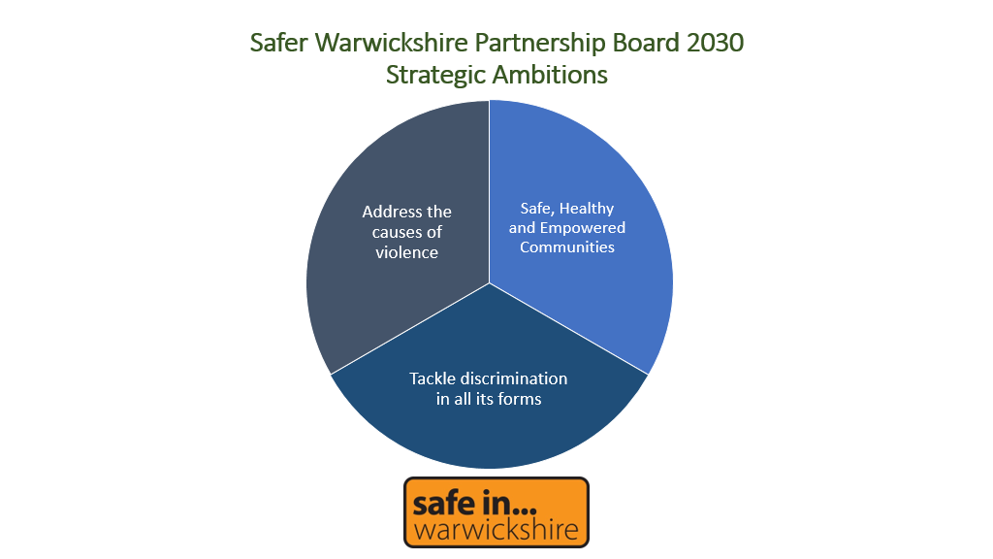

This agreement sets out the rationale, delivery mechanisms and outcomes to be used to measure success for each of the ambitions over the four year period 2022-26.
A review of the document will be undertaken and reported to the Safer Warwickshire Partnership Board annually, with a new agreement to be prepared in 2026 for the remaining four years of the ambitions and incorporating information available at that time from the next round of Strategic Assessments and new Police and Crime Plan.
Strategic ambitions, rationale, delivery mechanisms and outcomes
1) Address the causes of violence
Rationale
Serious violence, specifically gang, weapon and violence connected to county lines is the greatest concern and highest priority for partners and local community safety partnerships. Warwickshire is a net importer of county lines. Whilst, historically, drug supply lines have been brought into the area from other neighbouring locations, the county is experiencing greater levels of local recruitment into criminal networks which is increasing tensions and violence.

The Police Crime Sentencing and Courts Bill introduces a Duty to Tackle Serious Violence for named partners to work together to identify and publish what actions they need to take collectively to reduce violent crime” (Police Crime Sentencing and Courts Bill 2021). The duty requires partners to work together to share data, intelligence and knowledge to understand and address the root causes of serious violence including knife crime and will allow organisations to target their interventions to prevent and address violence. Partners are strongly encouraged to adopt a Public Health approach to implement this duty.

The partnership will develop a Serious Violence Prevention Strategy which will focus on addressing and delivering both countywide approaches and local interventions to address the causes of violence. A countywide framework will be adopted which incorporates the following established principles:
- The 5 C’s approach (collaboration, co-production, co-operation in data intelligence and sharing, a counter narrative, embedded in a community consensus approach)
- Delivering a trauma informed approach,
- Contextual safeguarding is embedded,
- Risk and protective factors are understood,
- Capricorn framework embedding a collaborative approach.
This framework will operate across partner organisations delivering a consistent approach to addressing serious violence.

It is expected by addressing the causes of violence Warwickshire will not only see a reduction in gang and knife crime, but over the life of this agreement, reductions in all forms of serious violence including:
- Domestic Abuse.
Over a third of all serious violence reports to Warwickshire police relate to Domestic Abuse. The prevalence and complexity of the cases are significant and it is known that reports to the police do not truly reflect the number of incidents as many incidents go unreported. Partnership work to address Domestic Abuse and its causes will continue to be a priority and will be addressed through partnership arrangements overseen by the Violence Against Women and Girls Board.
- Alcohol-related violence.
Violence related to the use of substances, most notably alcohol in the night-time economy, is a concern to many residents, businesses and partners. Working together in partnership, localised problem-solving plans are developed to prevent and address emerging trends. A countywide approach will be overseen by the newly formed Drug and Alcohol Partnership Board.
- Other forms of serious violence.
Serious Violence is often used as a tool to drive, threaten and enforce negative and criminal behaviour. Modern Slavery and Human Trafficking, acts of violence and terror, Harmful Practices (Female Genital Mutilation, forced marriages, so called honour based abuse), and serious and organised crime are all areas where Warwickshire partners come together to develop awareness and pathways of support and action.
Delivery Mechanisms
Work to address this ambition will be delivered through the following subgroups:
- Violence Against Women and Girls Board
- Serious and Organised Crime Joint Action Group
- Prevent Steering Group
- Reducing Reoffending Board
- Drug and Alcohol Partnership Board
This strategic ambition and associated work of the subgroups will directly link with the priorities of the Local Criminal Justice Board, Youth Justice Service Board and Health and Wellbeing Board.
Community Safety Partnerships and problem solving meetings will play a critical role in the delivery of this ambition at a local level.

Outcomes
Key outcomes of success will include:
- Implementation of preventative measures to reduce Adverse Childhood Experiences (ACEs)
- Embedding Contextual safeguarding across all community safety partners
- Public Health approach to addressing serious violence.
The detailed outcome measures to be used to measure success in the delivery of this ambition will be developed by partners during 2022-23.

2) Safe, Healthy and Empowered Communities
Rationale
Consultation undertaken as part of the 2021 review of the SWPB identified a wide range of current and emerging issues that will have a profound impact on Warwickshire’s communities and the work of community safety partners. These include:
- The Coronavirus pandemic, including its impact on mental wellbeing and levels of domestic abuse
- Brexit
- The global climate crisis, including the impact on modes of transport
- The changing shape and use of town centres
- Significant differences in health outcomes across the county, including length of life and years spent in ill health.
The importance of working alongside the Warwickshire Health and Wellbeing Board to help shape and deliver long term programmes to address these issues was recognised across the partnership. Community safety partners will seek to work with health colleagues to share skills, resources and knowledge to create places where people are resilient, recognise a future for themselves and their family and have a vested interest in.
Joint working to improve health outcomes, create safer communities and empower residents will be designed to have a positive impact across a range of community safety priority areas including:
- The misuse of drugs and alcohol, and their impact on levels of violence and acquisitive crime.
- As residents take pride in their communities, a reduction in the types of crime and anti-social behaviour often seen as lower level but which have a significant impact on the wellbeing of vulnerable individuals involved and can leave neighbourhoods feeling neglected.
- An increase in community cohesion and reduction in levels of hate crime and incidents.
- A reduction in Business Crime as residents feel they have a stake in their communities and a vested interest in the success of local businesses.
- Working alongside communities to understand locations that cause them concern, identifying options to reduce or eliminate these areas of concern. By empowering the local community to feel safe in their community, taking an active and vested interest in sustaining the improvements for the future.

Delivery Mechanisms
Work to address this ambition will be delivered through the following subgroups:
- Violence Against Women and Girls Board
- Hate Crime Partnership Board
- Prevent Steering Group
- Reducing Reoffending Board
- Drug and Alcohol Partnership Board
In addition to the joint work required with the Health and Wellbeing Board, this strategic ambition and associated work of the subgroups will directly link with the priorities of the Safeguarding Board and Thriving Communities Partnership.
Community Safety Partnerships and problem solving meetings will play a critical role in the delivery of this ambition at a local level.
Outcomes
Key outcomes of success will include:
- Community cohesion
- Responding to the changing nature of the economy and town centres
- Improve accessibility to health based support at the point of need
The detailed outcome measures to be used to measure success in the delivery of this ambition will be developed by partners during 2022-23.

3) Tackle discrimination in all its forms
Rationale
Tackling hate crime has been a strategic priority for community safety partners for a number of years. In addition, the partnership has prioritised the Prevent agenda, recognising the changing nature of extremism, with an increase of far right or no fixed ideology being the most common themes in Prevent referrals.
2020 and 2021 brought two other key issues into the spotlight. The murder of George Floyd was a catalyst for social justice movements to recognise the ongoing discrimination of culturally and ethnically diverse communities including Black and Asian communities. The murder of Sarah Everard in the spring of 2021 brought into sharp focus gender discrimination and has led to a reflection on programmes that focused on victim’s changing behaviour, rather than the deeper societal issues of gender disparity and misogyny.
The SWPB has a clear mandate to prevent crime and disorder. This includes developing policies and programmes that address the societal norms that result in parts of our communities being disproportionately impacted by crime. It is vital that partners develop a long term programme that can identify and address discrimination across our partnership organisations, within the institutions we work with and across the criminal justice system.
Section 17 of the Crime and Disorder Act 1998 will be an invaluable tool in enabling partners to implement this ambition. This sets out a statutory duty for all responsible authorities to consider the impact of all their functions and decisions on crime and disorder in their local area. The partnership will be encouraged to adopt an auditing tool to identify and address discrimination and support those affected by it, as well as ensuring broader community safety implications are considered across all work undertaken by responsible authorities.
Delivery Mechanisms
Work to address this ambition will be delivered through the following subgroups:
- Violence Against Women and Girls Board
- Hate Crime Partnership Board
- Prevent Steering Group
This strategic ambition and associated work of the subgroups will directly link with the priorities of the Safeguarding Board, Health and Wellbeing Board and Thriving Communities Partnership.
Community Safety Partnerships and problem solving meetings will play a critical role in the delivery of this ambition at a local level.
Outcomes
Key outcomes of success will include:
- Development of an Equalities Charter self assessment toolkit
- Use of Section 17 as an auditing tool
- Redefine our offer for those experiencing hate
The detailed outcome measures to be used to measure success in the delivery of this ambition will be developed by partners during 2022-23.

Delivery Mechanisms – Governance
The delivery structure of the SWPB was refreshed following the review undertaken in 2021. The mechanisms in place to deliver the ambitions and outcomes within this agreement are shown below.
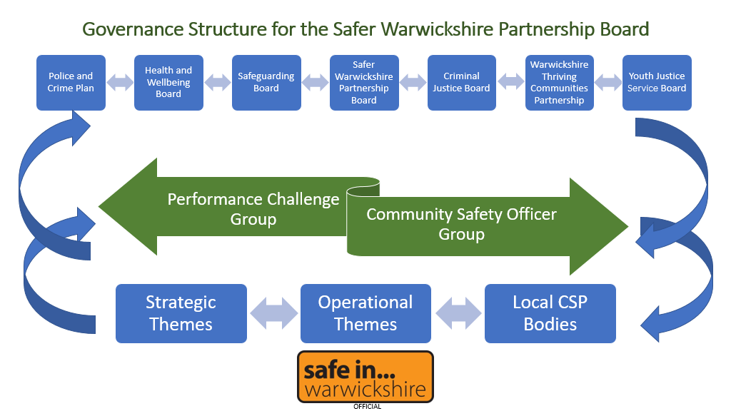
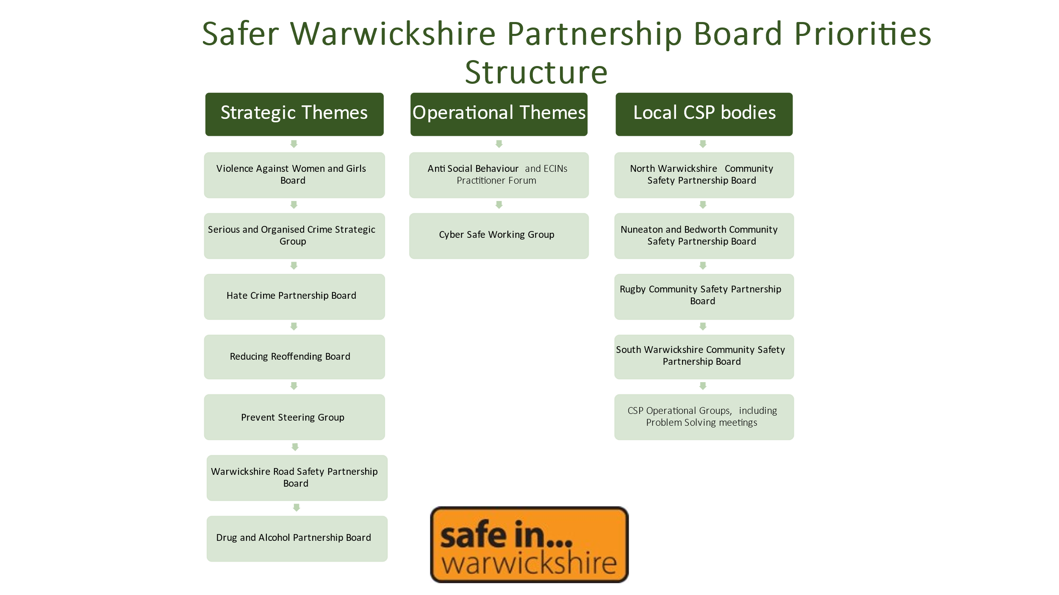

Appendices
The following documents can be accessed on the Safe In Warwickshire website: https://safeinwarwickshire.com/communitysafetyagreement/
- The community safety legal framework
- Outcomes of the SWPB Review
- Key achievements of the SWPB
- Terms of Reference for the SWPB
- The Community Safety Information Sharing Protocol
- The Police and Crime Plan
- Community Safety Partnership priorities
- The Strategic Assessment process.

